**CONTENT:**

**Employee Compensation:** Compensation & Welfare, Job Evaluation.

**Performance Appraisal:** Techniques, Job Enlargement & Job Enrichment, Quality of Work Life, Worker’s Participation in Management

**OUTCOME:**

Students will gain a comprehensive understanding of employee compensation, welfare, and job evaluation. Additionally, they will learn about various performance appraisal techniques, job enlargement and enrichment, quality of work life, and the importance of worker participation in management. This knowledge equips students with essential skills for effectively managing and enhancing employee performance and well-being in organizational settings.

**COMPENSATION:**



* Compensation refers to monetary payment given to an individual in exchange for their servicesTop of Form

.

* In the workplace, compensation is what is earned by employees. It includes salary or wages in addition to commission and any incentives or perks that come with the given employee's position.
* Paid employees as well as outside or temporary consultants are entitled to compensation, meaning the individual will be paid for the product or service they provide.
* Compensation is the remuneration awarded to an employee in exchange for their services or individual contributions to your business. The contributions can be their time, knowledge, skills, abilities, and commitment to your company or a project.
* In simpler words, compensation is the money received by an employee from an employer as a salary or wages.

**Types of Compensation**

* Compensation doesn’t mean only a paycheck, although that’s part of it.
* Compensation comprises a number of different elements which may be cash and non-cash payments.

**Here’s a list of some of the most common and commonly overlooked types of compensation:**

* Base pay (hourly or salary wages)
* Commissions
* Overtime Pay, shift differentials, and longevity pay
* Bonus
* Profit Sharing distributions
* Merit Pay or recognition
* Workers compensation or Workman’s comp
* Incentive plan or achievement award
* Tip income
* Benefits include Dental, insurance, medical, vacation, leaves, retirement, etc.
* Stock options
* Travel/Meal/Housing Allowance
* Child care and tuition assistance
* Gym memberships and free lunches
* Employee assistance programs that provide counseling, legal advice, and other services.
* Health and wellness benefits
* Other non-cash benefits

**WELFARE:**



* Welfare, in a general sense, refers to the well-being, health, happiness, and prosperity of individuals or groups.
* In the context of human resources and employment, employee welfare specifically pertains to the measures and initiatives implemented by organizations to enhance the overall quality of work life for their employees.
* Employee welfare programs are designed to create a positive and supportive work environment, address the non-monetary needs of employees, and contribute to their physical, mental, and emotional well-being.

Compensation and welfare are two essential components of human resource management that focus on employee well-being, motivation, and satisfaction within an organization.

1. **Compensation:**

* Compensation refers to the monetary and non-monetary rewards provided to employees in exchange for their work, services, time, and dedication to the organization.
* It encompasses various elements, including:

1. **Salary and Wages:** The basic monetary payment for the work performed by an employee.
2. **Bonuses and Incentives:** Additional financial rewards based on individual or collective performance to motivate and recognize employees.
3. **Benefits:** Non-monetary forms of compensation, such as health insurance, retirement plans, and other perks that contribute to the overall well-being of employees.
4. **Stock Options:** Providing employees with the opportunity to purchase company stock at a predetermined price, aligning their interests with the organization's success.

A well-structured compensation system is crucial for attracting and retaining talent, motivating employees, and ensuring internal equity within the organization.

1. **Welfare:**

* Employee welfare, often referred to as employee well-being, goes beyond financial compensation and encompasses the broader aspects of creating a healthy and conducive work environment.
* Welfare measures are designed to enhance the quality of work life for employees and foster a positive workplace culture.
* Some components of employee welfare include:

1. **Health and Safety Programs:** Ensuring a safe and healthy working environment, including safety protocols, training, and wellness programs.
2. **Work-Life Balance Initiatives:** Policies and practices that support a balance between work and personal life, such as flexible working hours, telecommuting, and family-friendly benefits.
3. **Employee Assistance Programs (EAPs):** Providing resources and support for employees facing personal or work-related challenges, including counseling services.
4. **Training and Development Opportunities:** Investing in the growth and skill development of employees through training programs, workshops, and educational opportunities.

Employee welfare initiatives contribute to higher job satisfaction, increased employee engagement, and a positive organizational culture. They play a crucial role in attracting and retaining top talent while promoting the overall well-being of the workforce.

Compensation focuses on the financial rewards for work, while welfare encompasses a broader range of initiatives aimed at promoting the overall well-being and satisfaction of employees in the workplace. Together, they form integral components of effective human resource management strategies.

**EMPLOYEE COMPENSATION:**

* Employee compensation refers to the combination of salary and wages, benefits, bonuses, and any additional perks employees receive for performing their job.
* Employee compensation refers to the total sum of financial and non-financial rewards provided to employees by an organization in exchange for their work, services, time, and dedication.
* Compensation is a critical component of the employer-employee relationship and plays a significant role in attracting, retaining, and motivating employees.
* It encompasses various elements, both monetary and non-monetary, aimed at recognizing and rewarding employees for their contributions to the organization.
* **Key components of employee compensation include:**

1. **Base Salary/Wages:** The fixed amount of money paid to an employee on a regular basis for their job responsibilities and time commitment.
2. **Bonuses and Incentives:** Additional payments made to employees based on individual or collective performance, meeting targets, or achieving specific goals. This includes performance bonuses, profit-sharing, and other incentive programs.
3. **Benefits:** Non-monetary forms of compensation provided to enhance the overall well-being of employees. Common benefits include health insurance, dental plans, retirement benefits, paid time off, and other perks.
4. **Stock Options and Equity:** Opportunities for employees to purchase or receive company stock at a predetermined price, aligning their interests with the organization's success.
5. **Allowances:** Additional payments or provisions for specific purposes, such as transportation allowances, housing allowances, or meal allowances.
6. **Vacation and Leave Policies:** Paid time off policies, including vacation days, sick leave, and other types of leave to support work-life balance and address personal needs.
7. **Recognition and Awards:** Formal acknowledgment of an employee's achievements or contributions, often accompanied by tangible rewards or certificates.
8. **Training and Development Opportunities:** Investments in the growth and skill development of employees through training programs, workshops, and educational support.

Effective compensation strategies are crucial for attracting and retaining top talent, maintaining internal equity within the organization, and motivating employees to perform at their best. Organizations often develop comprehensive compensation plans that take into account market conditions, industry standards, and the unique needs of their workforce to create a competitive and fair compensation structure.

**EMPLOYEES COMPENSATION ACT, 1923**

The Employee Compensation Act, 1923 came into force on 1st July, 1923, and provides social security to the workers. It was passed because accidents became frequent in the work areas, and one of the major reasons for that was the increasing use of advanced and sophisticated machinery. Hence, the act aims to secure the overall welfare of the workers.

**JOB EVALUATION:**

* Job evaluation is a systematic process of assessing the value of jobs in an organization in order to determine the worth of individual jobs and the compensation to be paid to employees who hold those jobs.
* The purpose of job evaluation is to ensure that employees are paid fairly for the work they do.
* Job evaluations are a step-by-step process to determine how much money a position should earn.
* There are different methods of job evaluation, but the point of each method is determining the value the position brings to the company. This ensures the salary is equal to the work.
* The HR department performs job evaluations based on the role rather than on the employee who holds the position. This typically occurs when a company is new or adding additional roles.
* Job Evaluation is defined as a systematic procedure used to ascertain the monetary worth of a role and is typically conducted by the HR department. In the realm of Human Resources, conducting a job evaluation might be a necessary task to establish the appropriate salary for a given role.
* By comparing the responsibilities of each position, job evaluations assist in ensuring fair compensation for all employees. Various methods exist for job evaluation, each aiming to quantify the value that a particular role contributes to the organization.
* Evaluations are role-based rather than employee-based, meaning they assess the position, not the individual occupying it. This is a common practice in newly established companies or when new roles are being introduced.

**JOB EVALUATION METHODS:**

Here are a few methods of job evaluation:

* Job evaluations, which are systematic processes to ascertain the monetary value of a position, can be categorized into two primary types: **Qualitative and Quantitative**.
* The qualitative methods, such as job ranking and classification, are typically quicker; while the quantitative methods, like factor comparison and point factor, take into account the skills and responsibilities required by each role.

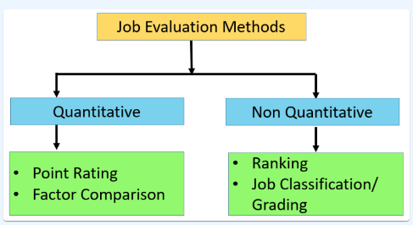

1. **Job Ranking:**

* This method involves arranging each role in a hierarchy, based on its value to the company or the complexity of its duties.
* It is particularly suitable for smaller companies due to its simplicity and can handle up to 100 jobs.
* It is also useful when reducing positions, as similar roles can be grouped together during the ranking process. However, it is subjective and may benefit from being combined with a quantitative method for more accurate results.

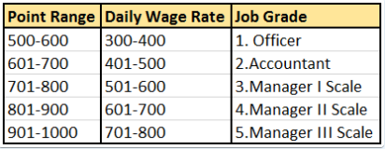

1. **Job Classification**:

* This method involves sorting roles based on a pre-established grading system or classification method.
* For instance, categories could include executives, skilled workers, semi-skilled workers, and unskilled workers.
* Each role is then placed into a category, which helps determine the salary for each position within that category.
* This method can be subjective and may struggle to categories unique

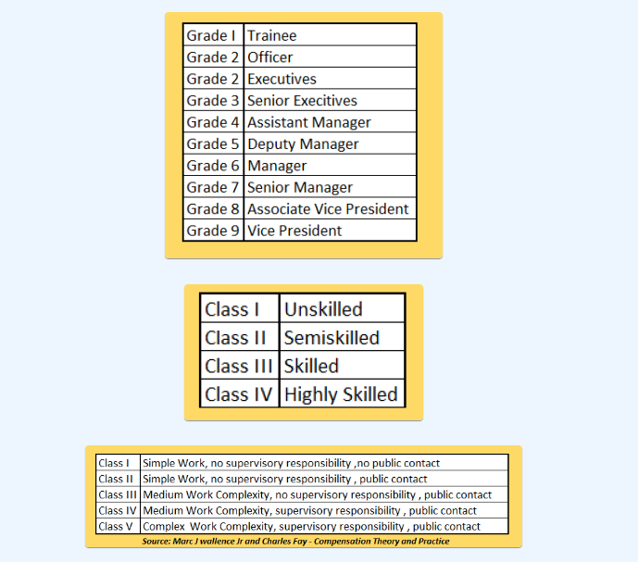roles.

1. **Point Factor**:

* This method involves assigning points to each role and then ranking them.
* A detailed point system is developed, where each skill or job responsibility could represent a point.
* The roles are then assigned a total number of points and ranked from highest to lowest to help determine their salaries.

1. **Factor Comparison**:

* This method combines the job ranking and point factor methods.
* Each job is ranked based on certain factors, such as the number of skills required or the necessary knowledge.
* These factors are then assigned points, and the total number of points determines the job’s ranking.

**PROCESS OF JOB EVALUATION:**

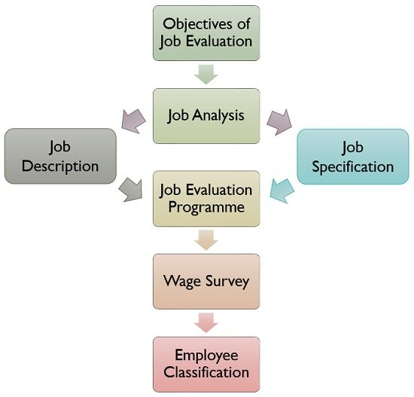

1. Job Evaluation process begins with the **establishment of objectives**, which is to fix an acceptable salary differential.
2. Next, **Job Analysis** is performed in order to gather information regarding the job, i.e. its nature and requirements. It helps in the preparation of**job description**and**job specification**.
3. After that, the **job evaluation programme** takes place in which jobs which require evaluation are identified, and evaluator is selected. Further, training is provided to the evaluator if necessary, criteria for the evaluation of jobs is determined, time involved in it is identified, and the method to be used for this purpose is decided.
4. Once the job evaluation is complete, the organizational hierarchy is created through an evaluation method and after that salary differential is established. For this purpose, the **wage rate is identified and the survey is performed**.
5. **Employee Classification** is the final step in the process of job evaluation, wherein job title is assigned to all the employees working in the organization.

The assessment of the jobs is based on the **job content**, i.e. duties and responsibilities involved, qualification, skills and experience required, intricacy involved in operations and working conditions. It is used to compare different jobs and place them as per their need and priority.

This results in the establishment of job hierarchy, which serves as a guide in the fixation of a rational pay structure.

**PERFORMANCE APPRAISAL:**

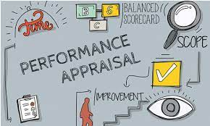

* A performance appraisal is a regular review of an employee’s job performance and contribution to a company.
* Performance appraisals are also called annual reviews, performance reviews or evaluations, or employee appraisals.
* A performance appraisal is a systematic and periodic process of measuring an individual’s work performance against the established requirements of the job.
* It’s a subjective evaluation of the employee’s strengths and weaknesses, relative worth to the organization, and future development potential.
* Performance appraisals are also called performance evaluations, [performance reviews](https://www.simplilearn.com/skills-training-for-performance-management-article), development discussions, or employee appraisals.
* A **performance appraisal** is a regular and structured method of assessing an employee's job performance with predetermined job expectations.
* It involves a subjective analysis of the individual's strengths and areas for improvement, their value to the organization, and their potential for future growth and development.

**PERFORMANCE APPRAISAL METHODS**

* With the right performance appraisal method, organizations can enhance employee performance within the organization.
* A good employee performance review method can make the whole experience effective and rewarding.

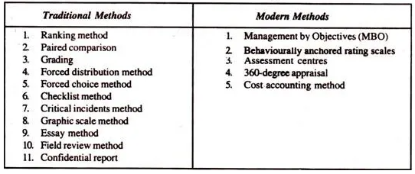

**Her**

1. **Traditional Methods**
2. **Ranking Method**

* It is the oldest and simplest formal systematic method of performance appraisal in which employee is compared with all others for the purpose of placing order of worth.
* The employees are ranked from the highest to the lowest or from the best to the worst.
* In doing this the employee who is the highest on the characteristic being measured and also the one who is L lowest, are indicated.
* Then, the next highest and the next lowest between next highest and lowest until all the employees to be rated have been ranked. Thus, if there are ten employees to be appraised, there will be ten ranks from 1 to 10.

1. **Paired Comparison**

* In this method, each employee is compared with other employees on one- on one basis, usually based on one trait only.
* The rater is provided with a bunch of slips each coining pair of names, the rater puts a tick mark against the employee whom he insiders the better of the two.
* The number of times this employee is compared as better with others determines his or her final ranking.

**N (N-1)/2**

Where N = the total number of employees to be evaluated.

1. **Grading Method**

* In this method, certain categories of worth are established in advance and carefully defined.
* There can be three categories established for employees: outstanding, satisfactory and unsatisfactory.
* There can be more than three grades. Employee performance is compared with grade definitions.
* The employee is, then, allocated to the grade that best describes his or her perfor­mance.

1. **Forced Distribution Method**

* This method was evolved by Tiffen to eliminate the central tendency of rating most of the employees at a higher end of the scale.
* The method assumes that employees’ performance level confirms to a normal statistical distribution i.e., 10,20,40,20 and 10 per cent.
* This is useful for rating a large number of employees’ job performance and promo ability. It tends to eliminate or reduce bias.
* It is also highly simple to understand and easy to apply in appraising the performance of employees in organizations. It suffer from the drawback that improve similarly, no single grade would rise in a ratings.

1. **Forced-Choice Method**

* The forced-choice method is developed by J. P. Guilford.
* It contains a series of groups of statements, and rater rates how effectively a statement describes each individual being evaluated.
* Common method of forced-choice method contains two statements, both positive and negative.

1. **Check-List Method**

* The basic purpose of utilizing check-list method is to ease the evaluation burden upon the rater.
* In this method, a series of statements, i.e., questions with their answers in ‘yes’ or ‘no’ are prepared by the HR department.
* The check-list is, then, presented to the rater to tick appropriate answers relevant to the appraisee.
* Each question carries a weight-age in relationship to their importance.

1. **Critical Incidents Method**

* In this method, the rater focuses his or her attention on those key or critical behaviours that make the difference between performing a job in a noteworthy manner (effectively or ineffectively).
* There are three steps involved in appraising employees using this method.

First, a list of noteworthy (good or bad) on-the-job behaviour of specific incidents is prepared. Second, a group of experts then assigns weightage or score to these incidents, depending upon their degree of desirability to perform a job. Third, finally a check-list indicating incidents that describe workers as “good” or “bad” is constructed. Then, the check-list is given to the rater for evaluating the workers.

1. **Graphic Rating Scale Method**

* The graphic rating scale is one of the most popular and simplest techniques for appraising performance. It is also known as linear rating scale.
* In this method, the printed appraisal form is used to appraise each employee.
* The form lists traits (such as quality and reliability) and a range of job performance characteristics (from unsatisfactory to outstanding) for each trait.
* The rating is done on the basis of points on the continuum. The common practice is to follow five points scale.

1. **Essay Method**

* Essay method is the simplest one among various appraisal methods available.
* In this method, the rater writes a narrative description on an employee’s strengths, weaknesses, past performance, potential and suggestions for improvement.
* Its positive point is that it is simple in use. It does not require complex formats and extensive/specific training to complete it.

1. **Field Review Method**

* When there is a reason to suspect rater’s biasedness or his or her rating appears to be quite higher than others, these are neutralized with the help of a review process.
* The review process is usually conducted by the personnel officer in the HR department.

1. **Confidential Report**

* It is the traditional way of appraising employees mainly in the Government Departments.
* Evaluation is made by the immediate boss or supervisor for giving effect to promotion and transfer.
* Usually a structured format is devised to collect information on employee’s strength weakness, intelligence, attitude, character, attendance, discipline, etc. report.

1. **Modern Methods**
2. **Management by Objectives (MBO)**

* Most of the traditional methods of performance appraisal are subject to the antagonistic judgments of the raters.
* It was to overcome this problem; Peter F. Drucker propounded a new concept, namely, management by objectives (MBO) way back in 1954 in his book.
* The Practice of management. The concept of MBO as was conceived by Drucker, can be described as a “process whereby the superior and subordinate managers of an organization jointly identify its common goals, define each individual’s major areas of responsibility in terms of results expected of him and use these measures as guides for operating the unit and assessing the contribution of each its members”.
* An MBO programme consists of four main steps: goal setting, performance standard, compari­son, and periodic review. In goal-setting, goals are set which each individual, s to attain.
* The superior and subordinate jointly establish these goals. The goals refer to the desired outcome to be achieved by each individual employee.
* In performance standards, the standards are set for the employees as per the previously arranged time period.
* When the employees start performing their jobs, they come to know what is to be done, what has been done, and what remains to be done.
* In the third step the actual level of goals attained are compared with the goals agreed upon. This enables the evaluator to find out the reasons variation between the actual and standard performance of the employees. Such a comparison helps devise training needs for increasing employees’ performance it can also explore the conditions having their bearings on employees’ performance but over which the employees have no control.
* Finally, in the periodic review step, corrective measure is initiated when actual performance deviates from the slandered established in the first step-goal-setting stage. Consistent with the MBO philosophy periodic progress reviews are conducted in a constructive rather than punitive manner.

1. **Behaviourally Anchored Rating Scales (BARS)**

* The problem of judgmental performance evalu­ation inherent in the traditional methods of performance evaluation led to some organizations to go for objective evaluation by developing a technique known as “Behaviourally Anchored Rating Scales (BARS)” around 1960s. BARS are descriptions of various degrees of behaviour with regard to a specific performance dimension.
* It combines the benefits of narratives, critical incidents, and quan­tified ratings by anchoring a quantified scale with specific behavioural examples of good or poor performance.
* The proponents of BARS claim that it offers better and more equitable appraisals than do the other techniques of performance appraisal we discussed so far.

1. **Assessment Centres**

* The introduction of the concept of assessment centres as a method of performance method is traced back in 1930s in the Germany used to appraise its army officers.
* The concept gradually spread to the US and the UK in 1940s and to the Britain in 1960s.
* The concept, then, traversed from the army to business arena during 1960s. The concept of assessment centre is, of course, of a recent origin in India.
* In India, Crompton Greaves, Eicher, Hindustan Lever and Modi Xerox have adopted this technique of performance evaluation.
* In business field, assessment centres are mainly used for evaluating executive or supervisory potential.
* By definition, an assessment centre is a central location where managers come together to participate in well-designed simulated exercises.
* They are assessed by senior managers supple­mented by the psychologists and the HR specialists for 2-3 days.
* Assessee is asked to participate in in-basket exercises, work groups, simulations, and role playing which are essential for successful performance of actual job. Having recorded the assessee’s behaviour the raters meet to discuss their pooled information and observations and, based on it, they give their assessment about the assesee. At the end of the process, feedback in terms of strengths and weaknesses is also provided to the assesees.

1. **360 – Degree Appraisal**

* Yet another method used to appraise the employee’s performance is 360 – degree appraisal.
* This method was first developed and formally used by General Electric Company of USA in 1992.
* Then, it travelled to other countries including India. In India, companies like Reliance Industries, Wipro Corporation, Infosys Technologies, Thermax, Thomas Cook etc., have been using this method for appraising the performance of their employees.
* This feedback based method is generally used for ascertaining training and development requirements, rather than for pay increases.
* Under 360 – degree appraisal, performance information such as employee’s skills, abilities and behaviours, is collected “all around” an employee, i.e., from his/her supervisors, subordinates, peers and even customers and clients.
* In other worlds, in 360-degree feedback appraisal system, an employee is appraised by his supervisor, subordinates, peers, and customers with whom he interacts in the course of his job performance.
* All these appraisers provide information or feedback on an employee by completing survey questionnaires designed for this purpose.

1. **Cost Accounting Method**

* This method evaluates an employee’s performance from the monetary benefits the employee yields to his/her organization.
* This is ascertained by establishing a relationship between the costs involved in retaining the employee, and the benefits an organization derives from Him/her.

**JOB ENLARGEMENT:**

* Job enlargement is the combining of job tasks across the same level within a company.
* Implementing job enlargement widens the scope of individual team members to include more tasks and responsibilities.
* By combining tasks, managers increase the interest and engagement in work among their teams.
* Effective job enlargement practices result in benefits for both managers and their staff, such as higher levels of productivity and morale. Using a job enlargement model increases the number of duties assigned to an individual, and this method gradually redefines the job by also increasing team member responsibilities and expectations.
* Job enlargement means the additional activities within the same level to an existing role. This means that a person will do more, different activities in their current job. **For example,** an employee who will now also manage her own planning where this was formerly done by her manager.
* Job enlargement is a key technique in [job redesign](https://www.aihr.com/blog/job-redesign/), along with [job enrichment](https://www.aihr.com/blog/job-enrichment/), job rotation, and job simplification.
* Job enlargement refers to the practice of increasing the scope of a job by adding more tasks or responsibilities to it. This strategy is aimed at providing employees with a greater variety of tasks and challenges within their existing role, thereby expanding their job responsibilities and potentially enhancing job satisfaction.
* The key idea behind job enlargement is to make the job more interesting and fulfilling by reducing monotony and increasing the diversity of tasks. This can lead to a more motivated and engaged workforce, as employees may find their work more stimulating and meaningful.
* Job enlargement differs from job enrichment, which involves enhancing a job by providing more complex and challenging tasks, as well as opportunities for skill development and advancement. Both job enlargement and job enrichment are strategies employed by organizations to improve employee satisfaction, motivation, and overall productivity.

**JOB ENRICHMENT**

* Job enrichment is a management strategy aimed at enhancing employees' job satisfaction and performance by increasing the depth and complexity of their work.
* Unlike job enlargement, which involves adding more tasks or responsibilities to a job, job enrichment focuses on improving the quality of the job by providing employees with opportunities for growth, skill development, and increased responsibility.
* Job enrichment is a technique used by organizations to improve the quality of work life and performance of their employees.
* Job enrichment is the process of increasing the range of activities and responsibilities an employee is involved in, in order to provide them with a more stimulating and satisfying work experience.
* By increasing the level of challenge and responsibility in a job, job enrichment can help employees feel more engaged and enthusiastic about their work, which can lead to improved performance and productivity.

**KEY DIFFERENCE BETWEEN BOTH:**

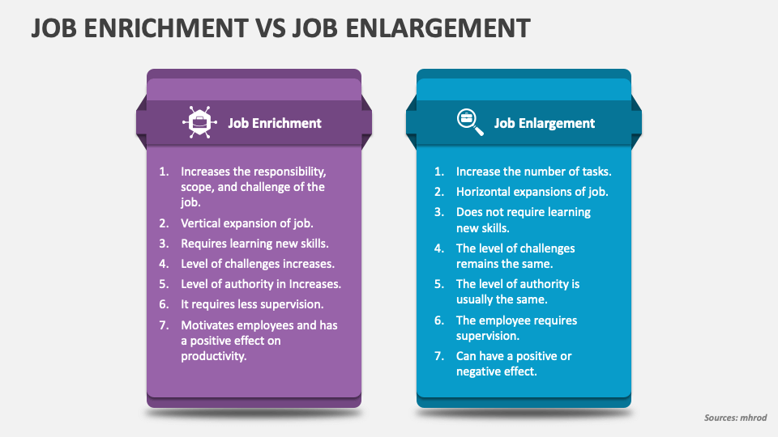

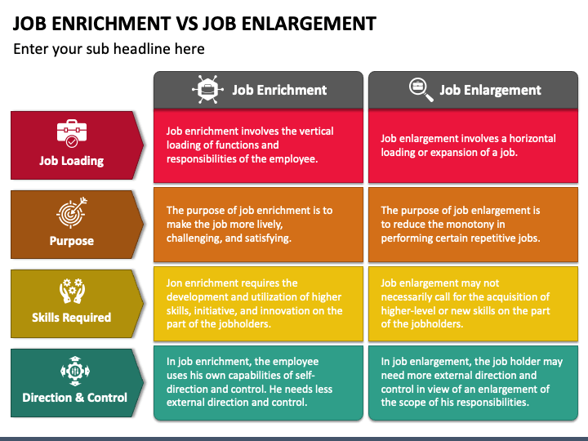

**QUALITY OF WORK LIFE (QWL)**

* “Quality of work life” is a generic phrase that covers a person’s feelings about every dimension of work including economic rewards and benefits, security, working conditions, organizational and interpersonal relationships, and its intrinsic meaning in a person’s life.
* The term Quality of Work Life (QWL) aims at changing the entire [organizational climate](https://www.mbaknol.com/management-concepts/concept-of-organizational-climate/) by humanizing work, individualizing organizations and changing the structural and managerial systems.
* It takes into consideration the socio-psychological needs of the employees. It seeks to create such a culture of work commitment in the organizations which will ensure [higher productivity](https://www.mbaknol.com/human-resource-management/need-of-workers-participation-in-management/) and greater job satisfaction for the employees.
* **Quality of work life** refers to the favourableness or unfavourableness of the job environment of an organization for its employees. It is generic term which covers a person’s feelings about every dimension of his work e.g. economic incentives and rewards, job security, working conditions, organizational and interpersonal relationships etc.

**Definitions of Quality of Work Life (QWL)** are as follows:

* **According to Harrison**: “**Quality of Work Life** is the degree to which work in an organization contributes to material and psychological well being of its members.”
* **According to D.S.Cohan** “**Quality of Work Life** is a process of joint decision making, collaborations and building mutual respect between management and employees.”
* **According to the American Society of Training and Development** “**Quality of Work Life** is a process of work organization which enables its members at all levels to participate actively and effectively in shaping the organizations’ environment, methods and outcomes. It is a value based process which is aimed towards meeting the twin goals of enhanced effectiveness of the organization and improved quality of life at work for the employees”.

**PRINCIPLES OF QUALITY OF WORK LIFE**

According to N.Q.Herrick and M.Maccoby there are four basic principles, which will humanize work and improve the Quality of Work Life:

1. **The Principle of Security**: Quality of work cannot be improved until employees are relieved of the anxiety, fear and loss of future employment. The working conditions must be safe and fear of economic want should be eliminated. Job security and safety against occupational hazards is an essential precondition of humanization of work.
2. **The Principle of Equity**: There should be a direct and positive relation between effort and reward. All types of discrimination between people doing similar work and with same level of performance must be eliminated. Equity also requires sharing the profits of the organization.
3. **The Principle of individualism**: Employees differ in terms of their attitudes, skills, potentials etc. Therefore, every individual should be provided the opportunities for development of his personality and potential. Humanization of work requires that employees are able to decide their own pace of activities and design of work operations.
4. **The Principle of Democracy**: This means greater [authority and responsibility](https://www.mbaknol.com/management-principles/decentralization-of-authority/) to employees. Meaningful [participation in decision making process](https://www.mbaknol.com/human-resource-management/workers-participation-in-management/) improves the quality of work life.

**WORKER’S PARTICIPATION IN MANAGEMENT:**

* Workers participation in management refers to the participation of the workers in the decision-making process of the organization.
* This has an incredibly positive impact on the mental and psychological health of the workers, and they are associated with the organization.
* Workmen participation, also known as worker participation, refers to the involvement of employees, particularly those at the operational or shop-floor level, in the decision-making processes and activities of an organization.
* This concept recognizes the value of including workers in discussions and decisions that affect their work, conditions, and overall well-being within the company.
* Workmen participation can take various forms, and the extent of involvement may vary depending on the organizational structure and culture.

**Definitions of Workers Participation In Management**

* **According to Keith Davis,**

SSS

“Participation refers to the mental and emotional involvement of a person in a group situation which encourages him to contribute to group goals and share the responsibility of achievement”.

* **According to Walpole,**

“Participation in Management gives the worker a sense of importance, pride and accomplishment; it gives him the freedom of opportunity for self-expression; a feeling of belongingness with the place of work and a sense of workmanship and creativity”.

**The concept of workers’ participation in management encompasses the following:**

* It provides scope for employees in decision-making of the organization.
* The participation may be at the shop level, departmental level or at the top level.
* The participation includes the willingness to share the responsibility of the organization by the workers.

**Levels of Workers Participation in Management**

There can be 5 levels of Management Participation or WPM:

1. **Information participation:** It ensures that employees are able to receive information and express their views pertaining to the matter of general economic importance.
2. **Consultative importance:** Here workers are consulted on the matters of employee welfare such as work, safety and health. However, final decision always rests with the top-level management, as employees’ views are only advisory in nature.
3. **Associative participation:** It is an extension of consultative participation as management here is under the moral obligation to accept and implement the unanimous decisions of the employees. Under this method the managers and workers jointly take decisions.
4. **Administrative participation:** It ensures greater share of workers’ participation in discharge of managerial functions. Here, decisions already taken by the management come to employees, preferably with alternatives for administration and employees have to select the best from those for implementation.
5. **Decisive participation:** Highest level of participation where decisions are jointly taken on the matters relating to production, welfare etc.

**MCQ’s:**

1. **Question: What is the primary purpose of employee compensation?**

A. Employee motivation  
B. Cost reduction  
C. Attract and retain talent  
D. Social responsibility

**Answer: C**

1. **Question: Which of the following is a component of direct financial compensation?**

A. Training programs  
B. Health insurance  
C. Base salary  
D. Flexible work hours

**Answer: C**

1. **Question: What does the term "total rewards" encompass in the context of employee compensation?**

A. Only financial benefits  
B. Only non-financial benefits  
C. Both financial and non-financial benefits  
D. Retirement benefits only

**Answer: C**

1. **Question: What is the purpose of job evaluation?**

A. Determine employee performance  
B. Establish pay grades for jobs  
C. Evaluate employee skills  
D. Set performance targets

**Answer: B**

1. **Question: Which compensation philosophy focuses on paying employees at or above market rates?**

A. Market-competitive  
B. Cost-minimization  
C. Equity-oriented  
D. Performance-based

**Answer: A**

1. **Question: Which type of benefits is aimed at improving the work-life balance of employees?**

A. Health insurance  
B. Flexible work hours  
C. Retirement plans  
D. Performance bonuses

**Answer: B**

1. **Question: What is the key objective of incentive compensation?**

A. Ensure legal compliance  
B. Reward employees for past performance  
C. Provide retirement benefits  
D. Attract new talent

**Answer: B**

1. **Question: In a job analysis, what does the term "job specification" refer to?**

A. Detailed information about a specific job  
B. Overall job market trends  
C. Employee performance reviews  
D. Compensation policies

**Answer: A**

1. **Question: Which of the following is a statutory benefit in most employment scenarios?**

A. Performance bonuses  
B. Health insurance  
C. Flexible work hours  
D. Stock options

**Answer: B**

1. **Question: What is the primary focus of a salary survey?**

A. Employee job satisfaction  
B. Market competitiveness of salaries  
C. Job evaluation results  
D. Employee training needs

**Answer: B**

1. **Question: How does variable pay differ from base salary?**

A. Variable pay is paid annually, while base salary is paid monthly.  
B. Variable pay is fixed, while base salary varies.  
C. Variable pay is tied to performance, while base salary is fixed.  
D. Base salary is paid only to executives.

**Answer: C**

1. **Question: Which of the following is an example of a non-financial benefit?**

A. Overtime pay  
B. Health insurance  
C. Performance bonuses  
D. Stock options

**Answer: B**

1. **Question: What is the purpose of a job grading system?**

A. Rank employees based on performance  
B. Classify jobs based on their relative worth  
C. Determine employee eligibility for promotions  
D. Set performance targets

**Answer: B**

1. **Question: In a pay-for-performance system, how are rewards typically distributed?**

A. Equally among all employees  
B. Based on seniority  
C. Based on individual and team performance  
D. Randomly

**Answer: C**

1. **Question: Which of the following is an indirect financial benefit?**

A. Base salary  
B. Overtime pay  
C. Health insurance  
D. Performance bonuses

**Answer: C**

1. **Question: What is the purpose of a flexible benefits plan?**

A. Increase fixed costs for the organization  
B. Provide employees with a range of benefit options  
C. Reduce employee motivation  
D. Eliminate all non-monetary benefits

**Answer: B**

1. **Question: What is the main goal of job enrichment?**

A. Increase job complexity  
B. Reduce employee workload  
C. Eliminate job positions  
D. Simplify job tasks

**Answer: A**

1. **Question: Which method is commonly used in job evaluation to determine the relative value of jobs?**

A. Ranking method  
B. Point factor method  
C. Factor comparison method  
D. Job classification method

**Answer: B**

1. **Question: What is the significance of a compensation philosophy?**

A. Determine employee job satisfaction  
B. Establish pay grades  
C. Communicate the organization's approach to compensation  
D. Assess employee performance

**Answer: C**

1. **Question: Which factor is NOT considered in a point factor system of job evaluation?**

A. Skill  
B. Responsibility  
C. Market demand  
D. Working conditions

**Answer: C**

1. **Question: Which of the following is a disadvantage of using a purely market-based approach to compensation?**

A. Increased employee motivation  
B. Difficulty in retaining top talent  
C. Greater cost for the organization  
D. Improved employee satisfaction

**Answer: C**

1. **Question: What does the term "golden handcuffs" refer to in the context of compensation?**

A. High base salary  
B. Stock options  
C. Incentive plans  
D. Financial incentives to retain employees

**Answer: D**

1. **Question: Which compensation strategy aims to ensure fairness and equity among employees?**

A. Market-competitive  
B. Pay-for-performance  
C. Internal equity  
D. Cost-minimization

**Answer: C**

1. **Question: What is the purpose of fringe benefits?**

A. Direct financial compensation  
B. Employee motivation  
C. Improve work-life balance  
D. Indirect financial compensation

**Answer: D**

1. **Question: How does a pay-for-performance system contribute to employee motivation?**

A. By providing fixed salaries  
B. By tying rewards to individual and team performance  
C. By eliminating all financial benefits  
D. By reducing job complexity

**Answer: B**

1. **Question: Which of the following is an example of an intrinsic reward?**

A. Performance bonus  
B. Flexible work hours  
C. Recognition and praise  
D. Overtime pay

**Answer: C**

1. **Question: What is the primary focus of a job description?**

A. Employee training needs  
B. Job market trends  
C. Detailed information about a specific job  
D. Employee performance reviews

**Answer: C**

1. **Question: Which type of job evaluation method involves assigning a numerical value to each job?**

A. Ranking method  
B. Factor comparison method  
C. Job classification method  
D. Point factor method

**Answer: D**

1. **Question: Which of the following is a potential drawback of an incentive compensation plan?**

A. Increased employee motivation  
B. Unintended focus on short-term goals  
C. Enhanced teamwork  
D. Improved organizational performance

**Answer: B**

1. **Question: What is the primary purpose of benchmarking in compensation?**

A. Determine employee performance  
B. Compare the organization's compensation practices with industry standards  
C. Establish pay grades  
D. Assess employee job satisfaction

**Answer: B**

1. **Question: How can organizations ensure pay equity?**

A. Ignore market trends  
B. Conduct regular salary surveys  
C. Base pay solely on individual performance  
D. Offer variable pay to all employees

**Answer: B**

1. **Question: What is the purpose of a compensation committee in an organization?**

A. Set individual performance targets  
B. Approve salary increases for all employees  
C. Review and recommend changes to the organization's compensation strategy  
D. Conduct job evaluations

**Answer: C**

1. **Question: What is the key consideration in establishing a pay structure?**

A. Employee job satisfaction  
B. Market competitiveness  
C. Seniority of employees  
D. Individual performance

**Answer: B**

1. **Question: Which of the following is an extrinsic reward?**

A. Job satisfaction  
B. Recognition and praise  
C. Base salary  
D. Career development opportunities

**Answer: C**

1. **Question: How does a merit-based compensation system operate?**

A. Rewards are based on job complexity  
B. Rewards are based on individual performance  
C. Rewards are distributed equally among all employees  
D. Rewards are based on seniority

**Answer: B**

1. **Question: What is the purpose of a cost-of-living adjustment (COLA) in compensation?**

A. Increase employee motivation  
B. Adjust salaries based on inflation rates  
C. Provide retirement benefits  
D. Determine individual performance

**Answer: B**

1. **Question: Which of the following is a potential challenge in implementing a pay-for-performance system?**

A. Increased employee motivation  
B. Difficulty in measuring performance objectively  
C. Enhanced teamwork  
D. Improved organizational performance

**Answer: B**

1. **Question: What is the primary focus of a job evaluation committee?**

A. Conduct salary surveys  
B. Review and recommend changes to job classifications  
C. Set individual performance targets  
D. Approve employee training programs

**Answer: B**

1. **Question: Which type of compensation philosophy emphasizes internal pay equity?**

A. Market-competitive  
B. Pay-for-performance  
C. Internal equity  
D. Cost-minimization

**Answer: C**

1. **Question: How does a cafeteria-style benefits plan operate?**

A. Employees are required to choose only financial benefits  
B. Employees can choose from a menu of benefit options  
C. Employees are given a fixed set of benefits  
D. Employees receive benefits based on job complexity

**Answer: B**

1. **Question: What is the purpose of a 360-degree feedback system in the context of employee compensation?**

A. Determine employee performance  
B. Gather feedback from multiple sources for a comprehensive performance assessment  
C. Establish pay grades  
D. Review market competitiveness

**Answer: B**

1. **Question: Which of the following is an example of an intangible benefit?**

A. Base salary  
B. Health insurance  
C. Employee recognition programs  
D. Overtime pay

**Answer: C**

1. **Question: In a pay-for-performance system, what is the purpose of a performance appraisal?**

A. Set individual performance targets  
B. Assess employee job satisfaction  
C. Evaluate employee performance for reward determination  
D. Conduct job evaluations

**Answer: C**

1. **Question: What role does the concept of equity play in compensation?**

A. Determining market competitiveness  
B. Ensuring fair and just treatment of employees  
C. Setting individual performance targets  
D. Establishing pay grades

**Answer: B**

1. **Question: Which benefits category includes programs that help employees balance work and personal responsibilities?**

A. Health insurance  
B. Retirement plans  
C. Welfare benefits  
D. Performance bonuses

**Answer: C**

1. **Question: What is the primary goal of a job rotation program?**

A. Increase employee motivation  
B. Enhance employee skills and knowledge  
C. Establish pay grades  
D. Determine market competitiveness

**Answer: B**

1. **Question: Which of the following is a common method for job evaluation based on compensable factors?**

A. Ranking method  
B. Point factor method  
C. Factor comparison method  
D. Job classification method

**Answer: C**

1. **Question: What is the purpose of a bonus program in compensation?**

A. Base salary adjustments  
B. Rewarding employees for exceptional performance  
C. Setting individual performance targets  
D. Assessing market competitiveness

**Answer: B**

1. **Question: Which term refers to the total value of an employee's compensation package?**

A. Base salary  
B. Total rewards  
C. Variable pay  
D. Fringe benefits

**Answer: B**

1. **Question: How does a flexible work arrangement contribute to employee welfare?**

A. Reduces job complexity  
B. Enhances work-life balance  
C. Ties rewards to individual performance  
D. Increases fixed costs for the organization

**Answer: B**

1. **Question: What is the purpose of a salary range in a pay structure?**

A. Set individual performance targets  
B. Provide a range for compensation within a job grade  
C. Determine market competitiveness  
D. Eliminate variable pay

**Answer: B**

1. **Question: In a job analysis, what is the focus of the task-oriented approach?**

A. Employee motivation  
B. Detailed information about a specific job  
C. Establishing pay grades  
D. Employee recognition programs

**Answer: B**

1. **Question: Which of the following is a legal consideration in designing compensation packages?**

A. Employee preferences  
B. Market competitiveness  
C. Social responsibility  
D. Job complexity

**Answer: C**

1. **Question: What is the primary purpose of a deferred compensation plan?**

A. Rewarding employees for past performance  
B. Postponing the distribution of a portion of an employee's earnings  
C. Setting individual performance targets  
D. Assessing market competitiveness

**Answer: B**

1. **Question: Which of the following is an intrinsic benefit of job enrichment?**

A. Increased job complexity  
B. Enhanced work-life balance  
C. Overtime pay  
D. Retirement plans

**Answer: B**

1. **Question: How does job sharing contribute to employee welfare?**

A. Reduces job complexity  
B. Enhances work-life balance  
C. Ties rewards to individual performance  
D. Increases fixed costs for the organization

**Answer: B**

1. **Question: What is the purpose of a profit-sharing plan?**

A. Increase employee motivation  
B. Reward employees based on the organization's financial success  
C. Set individual performance targets  
D. Assess market competitiveness

**Answer: B**

1. **Question: Which method of job evaluation involves comparing jobs based on predetermined compensable factors?**

A. Ranking method  
B. Point factor method  
C. Factor comparison method  
D. Job classification method

**Answer: B**

1. **Question: What is the primary goal of a wellness program in an organization?**

A. Enhance employee skills  
B. Increase job complexity  
C. Improve employee health and well-being  
D. Determine market competitiveness

**Answer: C**

1. **Question: How does a non-compete clause in a employment contract impact compensation?**

A. Reduces employee motivation  
B. Restricts employees from seeking alternative employment after leaving the organization  
C. Ties rewards to individual performance  
D. Enhances work-life balance

**Answer: B**

1. **Question: What is the primary purpose of performance appraisal?**

A. Determine employee workload  
B. Evaluate employee performance  
C. Set individual performance targets  
D. Assess market competitiveness

**Answer: B**

1. **Question: Which performance appraisal technique involves ranking employees from highest to lowest performance?**

A. Graphic Rating Scale  
B. Forced Distribution  
C. Critical Incident Technique  
D. Behaviorally Anchored Rating Scale (BARS)

**Answer: B**

1. **Question: What is the main advantage of the Critical Incident Technique in performance appraisal?**

A. Provides a holistic view of employee performance  
B. Simplifies the evaluation process  
C. Reduces subjectivity  
D. Allows for easy comparison of employees

**Answer: A**

1. **Question: Which of the following is a potential drawback of the Graphic Rating Scale method?**

A. High subjectivity  
B. Requires extensive training for evaluators  
C. Time-consuming  
D. Difficult to understand

**Answer: A**

1. **Question: How does the Forced Distribution method categorize employee performance?**

A. Into three categories: top, middle, and bottom performers  
B. Based on a numerical scale  
C. Comparing employees to a set standard  
D. Through open-ended discussions

**Answer: A**

1. **Question: What is the primary goal of job enlargement?**

A. Increase job complexity  
B. Enhance employee skills  
C. Reduce employee workload  
D. Expand the scope of an employee's responsibilities

**Answer: D**

1. **Question: How does job enrichment differ from job enlargement?**

A. Job enrichment focuses on increasing job complexity, while job enlargement focuses on expanding job tasks.  
B. Job enrichment and job enlargement are synonymous terms.  
C. Job enlargement focuses on increasing job complexity, while job enrichment focuses on expanding job tasks.  
D. Job enrichment only applies to managerial positions.

**Answer: A**

1. **Question: What is the key objective of quality of work life programs?**

A. Increase job complexity  
B. Enhance the well-being of employees in the workplace  
C. Determine market competitiveness  
D. Set individual performance targets

**Answer: B**

1. **Question: Which factor is NOT typically associated with the quality of work life?**

A. Work-life balance  
B. Job security  
C. Job complexity  
D. Employee engagement

**Answer: C**

1. **Question: How can organizations improve the quality of work life for employees?**

A. Increase job complexity  
B. Provide opportunities for skill development  
C. Implement flexible work arrangements  
D. Set individual performance targets

**Answer: C**

1. **Question: What is the primary focus of workers' participation in management?**

A. Set individual performance targets  
B. Enhance employee skills  
C. Involve employees in decision-making processes  
D. Assess market competitiveness

**Answer: C**

1. **Question: Which form of workers' participation in management involves employees having a say in decision-making through elected representatives?**

A. Quality Circles  
B. Joint Management Councils  
C. Suggestion Boxes  
D. Collective Bargaining

**Answer: B**

1. **Question: What is the primary purpose of suggestion boxes in workers' participation?**

A. Assess market competitiveness  
B. Encourage employees to provide input and suggestions  
C. Set individual performance targets  
D. Enhance employee skills

**Answer: B**

1. **Question: Which quality of work life factor relates to an employee's perception of being fairly treated?**

A. Job security  
B. Equity and fairness  
C. Work-life balance  
D. Job complexity

**Answer: B**

1. **Question: Which performance appraisal technique uses specific, observable incidents to evaluate employee behavior?**

A. Graphic Rating Scale  
B. Critical Incident Technique  
C. Forced Distribution  
D. Behaviorally Anchored Rating Scale (BARS)

**Answer: B**

1. **Question: What is the primary focus of a Joint Management Council in workers' participation?**

A. Determine market competitiveness  
B. Enhance employee skills  
C. Involve employees in decision-making processes  
D. Assess individual performance

**Answer: C**

1. **Question: In job enlargement, what is the primary approach to increasing the scope of a job?**

A. Vertical expansion  
B. Horizontal expansion  
C. Reducing job complexity  
D. Limiting job tasks

**Answer: B**

1. **Question: Which of the following is a potential disadvantage of job enrichment?**

A. Increased job satisfaction  
B. Resistance from employees  
C. Reducing job complexity  
D. Improved employee motivation

**Answer: B**

1. **Question: How does Quality Circles contribute to the quality of work life?**

A. Increases job complexity  
B. Enhances employee skills  
C. Involves employees in problem-solving and decision-making  
D. Determines market competitiveness

**Answer: C**

1. **Question: What is the primary purpose of job rotation in organizations?**

A. Increase job complexity  
B. Enhance employee skills and knowledge  
C. Reduce employee workload  
D. Assess individual performance

**Answer: B**

1. **Question: Which performance appraisal technique combines elements of both narrative and quantified ratings?**

A. Graphic Rating Scale  
B. Forced Distribution  
C. Behaviorally Anchored Rating Scale (BARS)  
D. Critical Incident Technique

**Answer: C**

1. **Question: What is the main advantage of the Behaviorally Anchored Rating Scale (BARS) method?**

A. Reduces subjectivity  
B. Simplifies the evaluation process  
C. Requires minimal training for evaluators  
D. Focuses on numerical ratings

**Answer: A**

1. **Question: How does a job characteristic model contribute to job enrichment?**

A. By reducing job complexity  
B. By identifying core job characteristics that lead to high job satisfaction  
C. By limiting the scope of job tasks  
D. By increasing employee workload

**Answer: B**

1. **Question: What is the primary goal of workers' participation through Quality Circles?**

A. Enhance employee skills  
B. Determine market competitiveness  
C. Involve employees in problem-solving and decision-making  
D. Set individual performance targets

**Answer: C**

1. **Question: Which performance appraisal technique involves the evaluation of specific, measurable goals?**

A. Graphic Rating Scale  
B. Management by Objectives (MBO)  
C. Forced Distribution  
D. Behaviorally Anchored Rating Scale (BARS)

**Answer: B**

1. **Question: What is the primary purpose of a Job Diagnostic Survey in job enrichment?**

A. Assess individual performance  
B. Identify key aspects of a job that contribute to employee satisfaction  
C. Determine market competitiveness  
D. Reduce job complexity

**Answer: B**

1. **Question: How does flexible work scheduling contribute to the quality of work life?**

A. Increases job complexity  
B. Enhances work-life balance  
C. Reduces employee workload  
D. Determines market competitiveness

**Answer: B**

1. **Question: What is the purpose of a 360-degree feedback system in performance appraisal?**

A. Assess market competitiveness  
B. Evaluate employee performance from multiple perspectives  
C. Set individual performance targets  
D. Determine individual job complexity

**Answer: B**

1. **Question: What is the primary goal of workers' participation through Suggestion Boxes?**

A. Enhance employee skills  
B. Encourage employees to provide input and suggestions  
C. Involve employees in problem-solving and decision-making  
D. Determine market competitiveness

**Answer: B**

1. **Question: In job enlargement, what is the primary goal of horizontal expansion?**

A. Increase job complexity  
B. Enhance employee skills  
C. Provide additional tasks at the same level of skill  
D. Reduce employee workload

**Answer: C**

1. **Question: How does a compressed workweek contribute to the quality of work life?**

A. Increases job complexity  
B. Enhances work-life balance  
C. Reduces employee workload  
D. Determines market competitiveness

**Answer: B**

1. **Question: Which of the following is a potential challenge in implementing a 360-degree feedback system?**

A. Increased subjectivity  
B. Limited perspectives on employee performance  
C. Reduced employee motivation  
D. Difficulty in administering the feedback process

**Answer: B**

1. **Question: What is the primary focus of workers' participation through Collective Bargaining?**

A. Enhance employee skills  
B. Determine market competitiveness  
C. Negotiate terms and conditions of employment  
D. Involve employees in decision-making

**Answer: C**

1. **Question: How does a flexible benefits plan contribute to the quality of work life?**

A. Increases job complexity  
B. Enhances work-life balance  
C. Reduces employee workload  
D. Determines market competitiveness

**Answer: B**

1. **Question: What is the primary purpose of a behavior-focused performance appraisal?**

A. Evaluate specific incidents of employee behavior  
B. Determine market competitiveness  
C. Set individual performance targets  
D. Assess overall job complexity

**Answer: A**

1. **Question: How does workers' participation in decision-making contribute to organizational effectiveness?**

A. Increases job complexity  
B. Enhances employee skills  
C. Improves employee morale and commitment  
D. Reduces employee workload

**Answer: C**

1. **Question: Which job characteristic is associated with job enrichment in the Job Characteristics Model?**

A. Task significance  
B. Market competitiveness  
C. Job complexity  
D. Overtime pay

**Answer: A**

1. **Question: What is the primary goal of workers' participation through Joint Management Councils?**

A. Enhance employee skills  
B. Determine market competitiveness  
C. Involve employees in decision-making processes  
D. Set individual performance targets

**Answer: C**

1. **Question: In a job enrichment context, what does autonomy refer to?**

A. Reducing job complexity  
B. Enhancing employee skills  
C. Giving employees control over their work  
D. Assessing market competitiveness

**Answer: C**

1. **Question: How does a performance improvement plan contribute to the quality of work life?**

**A. Increases job complexity  
B. Provides additional tasks  
C. Enhances employee skills  
D. Sets clear expectations and goals for improvement**

**Answer: D**

1. **Question: What is the primary focus of workers' participation through Employee Involvement Teams?**

A. Enhance employee skills  
B. Determine market competitiveness  
C. Involve employees in decision-making processes  
D. Set individual performance targets

**Answer: C**

1. **Question: In a job enlargement context, what is the primary goal of vertical expansion?**

A. Increase job complexity  
B. Enhance employee skills  
C. Provide additional tasks at a higher skill level  
D. Reduce employee workload

**Answer: C**

1. **Question: What is the primary purpose of the Management by Objectives (MBO) performance appraisal method?**

A. Evaluate specific, measurable goals  
B. Determine market competitiveness  
C. Set individual performance targets  
D. Assess overall job complexity

**Answer: A**

1. **Question: How does workers' participation through Quality Circles contribute to organizational effectiveness?**

A. Increases job complexity  
B. Enhances employee skills  
C. Improves problem-solving and decision-making  
D. Reduces employee workload

**Answer: C**